Slough Borough Council
Review of Polling Districts, Polling Places and Polling Stations 2022/23 Report of The Returning Officer

Contents
Introduction and Background 3
Roles and Responsibilities and Definition of Terms 4
Accessibility Considerations 5
New Wards effective May 2023 6
Parishes, New polling stations & options 7

Proposed Polling Districts & Polling Stations
(Includes electorates as of 1st January 2023)
Baylis & Salt Hill Ward 8
Britwell Ward 9
Chalvey Ward 10
Cippenham Green Ward 11
Cippenham Manor Ward 12
Cippenham Village Ward 13
Colnbrook & Poyle Ward 14
Elliman Ward 15
Farnham Ward 16
Haymill Ward 17
Herschel Park Ward 18
Langley Foxborough Ward 19
Langley Marish Ward 20
Langley Meads Ward 21
Langley St Mary’s Ward 22
Manor Park & Stoke Ward 23
Northborough & Lynch Hill Valley Ward 24
Slough Central Ward 25
Upton Ward 26
Upton Lea Ward 27
Wexham Court Ward 28

Introduction and Background
Under the provisions within section 18C of the Representation of the People Act 1983 (as amended by section 17 of the Electoral Registration and Administration Act 2013), Slough Borough Council has undertaken a review of its polling districts and polling places.
The previous statutory review of all polling districts and polling places in Slough was undertaken in 2018.
The Local Government Boundary Commission for England (LGBCE) has since reviewed all of the ward boundaries in Slough which will now consist of 21 wards, an increase of six. The number of councillors will remain at 42, who will represent 21 two-councillor wards across the borough.
As a result a further review of the polling districts and places is required before the changes are implemented in time for the full local council elections to be held, subject to parliamentary approval, on Thursday 4 May 2023.
A Notice of Review of Polling Districts and Places has been published on 4 January 2023 seeking representations and views from residents, political parties, local councillors and persons or groups possessing particular expertise in relation to access to possible polling places. Representations, comments and feedback is sought on any aspect of the proposed polling districts or polling places set out in this report. The aim of the review is to ensure that:
- All electors have as reasonable facilities for voting as are practicable in the circumstances; and that
- So far as is reasonable and practicable that the polling places are accessible to all electors having regard to the accessibility needs of disabled persons
- To attempt to take into account current polling districts forming new polling districts or a major part thereof, where this can be achieved to ensure continuity where possible
- To attempt to take into account natural boundaries for example railway lines, major roads and rivers
The deadline to respond to this consultation is 18 January 2023.

Roles and responsibilities and definition of terms

The Council
The statutory responsibility for reviewing UK Parliamentary polling districts and places rests with each relevant local authority in Great Britain for so much of any constituency as is situated in its area.
The decision to make changes to polling districts and polling places will be made at a meeting of the full Council to be held on 26 January 2023.

The Electoral Registration Officer (ERO)
Where a local authority makes any alterations to the polling districts within its area, the ERO must amend the register of electors accordingly – either on a notice of alteration by publishing a revised register, or by publishing a revised register. The changes to the register take effect on the date that the ERO publishes a separate notice stating that the alterations have been made, which should be done to coincide with the publication of a notice of alteration/publication of a revised register.
Slough intend to republish the revised register of electors based on the new polling scheme on 1 February 2023. The last such register based on the existing wards was therefore published on 1 December 2022.

The (Acting) Returning Officer
The election rules require the (Acting) Returning Officer to decide how many polling stations are required for each polling place and they must allocate electors to the polling stations in such a manner as they think most convenient.

The Boundary Commission for England
Legislation has established the Boundary Commission for England to keep under review the boundaries of Parliamentary constituencies and Local Government boundaries in England. Reviews for boundary changes to wards and parliamentary constituencies are the Boundary Commission’s remit and not the Council’s.

Accessibility Considerations
The Council has a duty to ensure the accessibility of all polling places to disabled voters and has considered this for all polling places as part of this review. Specifically, the Council has given consideration to the Scope 2020 report ‘Polls Apart 2010: Opening Elections to Disabled People’. The main physical access issues identified by scope which have been considered as part of this review are:
- Polling places with steps into the entrance
- Narrow doorways and corridors
- Lack of space within the polling place to manoeuvre motorised wheelchairs
- Lack of space and secrecy for electors and their companions to discuss the elector’s choice of vote
- Lack of low level polling booths that provide voters with the confidence that they can cast their vote in secrecy
- Lack of chairs to enable people to rest
- Inadequate lighting
Unless explicitly discussed in the comments for each polling district, all polling places meet these requirements either through the existing infrastructure of the building or through the provision of temporary auxiliary aids to improve accessibility.
All polling stations are issued with low level polling booths with secrecy screens and temporary ramps are deployed where required. Polling station accessibility is kept under review in advance of each election through inspections and between elections through elector surveys and feedback.

New Wards Effective May 2023
The boundaries of all wards have changed, none have remained the same.
Below is a table of all the new wards. This also shows how many Councillors will be elected to represent each ward. Some of these new wards may sit within more than one existing parliamentary constituency. Currently proposed parliamentary constituencies as per the initial proposals published by the Parliamentary Boundary Commission for England will change the current arrangement of wards within parliamentary constituencies. Final recommendations are to be published in June 2023.
New Ward | No. of Councillors | No. of polling Districts | No. of Polling Places | Constituency
Baylis & Salt Hill | 2 | 3 | 3 | Slough
Britwell | 2 | 2 | 2 | Slough
Chalvey | 2 | 2 | 2 | Slough
Cippenham Green | 2 | 2 | 2 | Slough
Cippenham Manor | 2 | 2 | 2 | Slough
Cippenham Village | 2 | 2 | 2 | Slough
Colnbrook & Poyle | 2 | 3 | 3 | Windsor
Elliman | 2 | 2 | 2 | Slough
Farnham | 2 | 2 | 2 | Slough
Haymill | 2 | 2 | 2 | Slough
Herschel Park | 2 | 2 | 2 | Slough
Langley Foxborough | 2 | 2 | 2 | Windsor
Langley Marish | 2 | 2 | 2 | Windsor  (Part Slough)
Langley Meads | 2 | 2 | 2 | Slough
Langley St Mary’s | 2 | 2 | 2 | Slough  (part Windsor)
Manor Park & Stoke | 2 | 2 | 2 | Slough
Northborough & Lynch Hill Valley | 2 | 2 | 2 | Slough
Slough Central | 2 | 2 | 2 | Slough
Upton | 2 | 2 | 2 | Slough
Upton Lea | 2 | 2 | 2 | Slough
Wexham Court | 2 | 3 | 3 | Slough
Totals | 42 | 45 | 45
Total electorate as of 1st January 2023 is 99,635.

Parishes
All parish areas are completely contained within their own polling district. Further amendments to parish ward boundaries affected by ward changes will need to be undertaken by Community Governance Reviews.

Situation of New Polling Stations
The proposed scheme includes a total of 10 new polling stations which have all been assessed and have been deemed suitable to be used as polling stations.
Polling District | Polling Station | Address
BAA | The Centre | Farnham Road, SL1 4UT
CAA | Pakistani Welfare Association | 50 Davills Lane, SL1 2PH
CGA | St Andrew’s Shared Church | Washington Drive, SL1 5RE
CMB | Montem Primary School | Chalvey Grove, SL1 2TE
CVA | The Westgate School | Cippenham Lane, SL1 5AH
CPA | The Marriott Hotel | Ditton Road, SL3 8PT
CPB | The Holiday Inn | London Road, SL3 8QB
LAA | Langley Library | Trelawney Avenue, SL3 7UF
LAB | Marish Primary School | Swabey Road, SL3 8NZ
SCB | The Curve Library | 10 Wellington Street, SL1 1XY

Options for Specified Wards
Comments or observations are particularly sought for 2 wards where 2 potential locations for polling stations have been identified in each:
- Chalvey Ward - Polling District CAA - Page 10
- Cippenham Green Ward - Polling District CGA - Page 11
- Langley Marish Ward - Polling Districts LAA & LAB - Page 20

Baylis and Salt Hill Ward
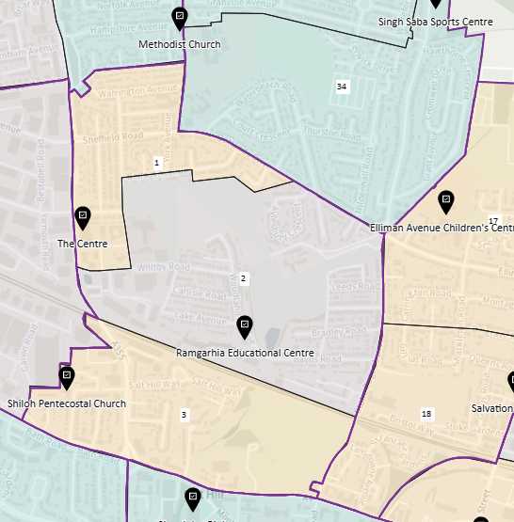
PD No. | Polling District | Polling Place | No. of Electors | Status
1 | BAA | The Centre, Farnham Road, SL1 4UT | 1492 | New
2 | BAB | Ramgarhia Education Centre, Woodland Avenue SL1 3BU | 2178 | Existing
3 | BAC | Shiloh Pentecostal Church,  17 Pitts Road SL1 3XG | 1266 | Existing
Total electors: 4936
Ward has been divided into 3 polling districts due to the high number of voters (over 3,500) north of the railway line (BAC).
BAA New polling district and place to serve area previously part of Farnham ward.
BAB Covers existing polling district BSC and part of Elliman ward (ELB).
BAC Provides a polling place for voter’s south of the main railway line

Britwell Ward
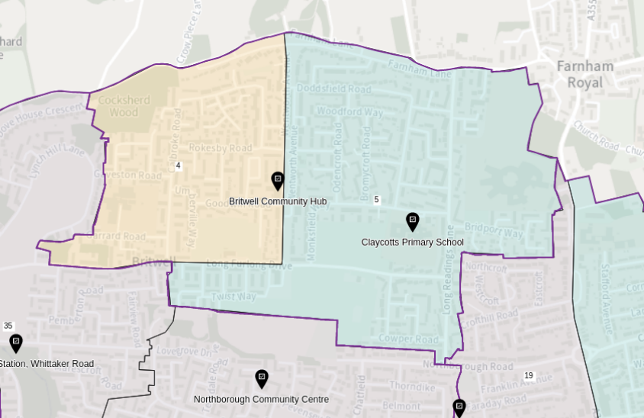
PD No. | Polling District | Polling Place | No. of Electors | Status
4 | BRA | Britwell Community Hub, Wentworth Avenue, SL2 2DS | 1807 | Existing
5 | BRB | Claycots School, Monksfield Way,  SL1 3UQ | 3166 | Existing
Total electors: 4973
BRA Contains the whole area of Britwell parish ward which must retain its own polling district.
BRB Area east of Wentworth Avenue and part of current Britwell & Northborough ward (BNB).

Chalvey Ward
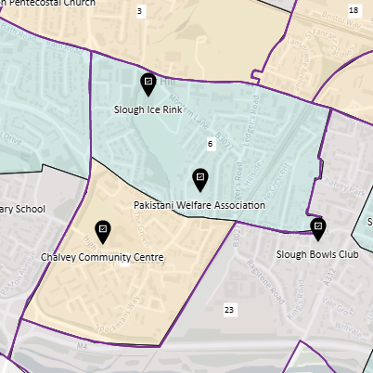
PD No. | Polling District | Polling Place | No. of Electors | Status
6 | CAA | Slough Ice Rink,  Montem Lane, SL1 2QG  or  Pakistani Welfare Association(PWA),  50 Davills Lane, SL1 2PH | 2498 | Slough Ice Rink: Existing  and  PWNA: New
7 | CAB | Chalvey Community Centre,  Ladbrooke Road, SL1 2SR | 1319 | Existing
Total electors: 3817
CAA Options are to continue the use of Slough Ice Rink to the east of the polling district or relocate the polling station to a new more central location for voters at Pakistani Welfare Association (availability subject to building works).
CAB Ward divided into 2 polling districts by Church Street (North/South) split. NB: previous PD CHC (680 voters) in CAA PD to locate to CAB if PWA unavailable.

Cippenham Green Ward
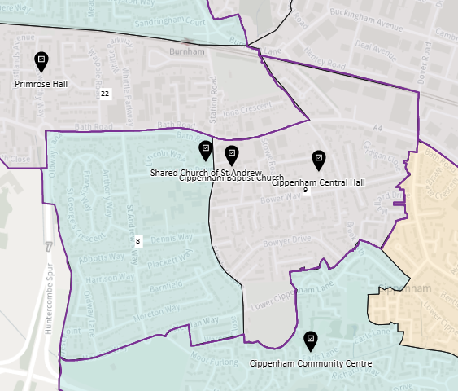
PD No. | Polling District | Polling Place | No. of Electors | Status
8 | CGA | Cippenham Baptist Church,  11 Elmshott Lane, SL1 5QS  or  St Andrew’s Shared Church,  Washington Drive, SL1 5RE | 2847 | Baptist Church: Existing  and  St Andrew’s: New
9 | CGB | Cippenham Central Hall,  Central Drive, SL1 5DD | 2199 | Existing
Total electors: 5046
CGA Options are to continue the use of Cippenham Baptist Church just outside the polling district or relocate to a new location of St Andrew’ Shared Church just west of Elmshott Lane (subject to availability).
CGB Ward divided into 2 polling districts by Elmshott Lane (East/West) split.

Cippenham Manor Ward
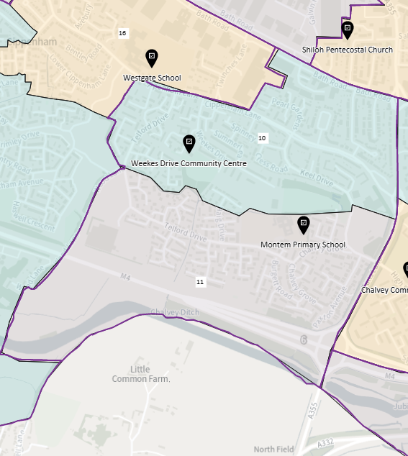
PD No. | Polling District | Polling Place | No. of Electors | Status
10 | CMA | Weekes Drive Community Hall,  4 Tamarisk Way, SL1 2YN | 2895 | Existing
11 | CMB | Montem Primary School,  Chalvey Grove, SL1 2TE | 2323 | New
Total electors: 5218
CMA & CMB Ward divided into 2 polling districts (North/South) split by stream.

Cippenham Village Ward
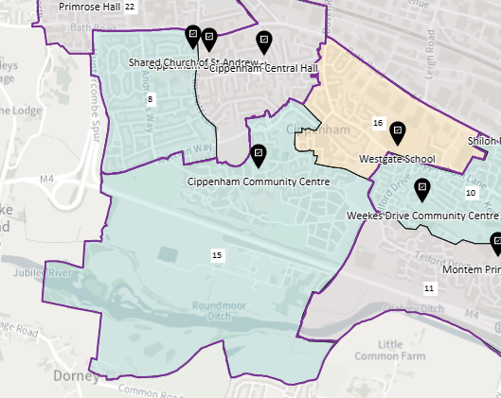
PD No. | Polling District | Polling Place | No. of Electors | Status
15 | CVA | Cippenham Community Centre,  Earls Lane, SL1 5TD | 1733 | Existing
16 | CVB | Westgate School,  Cippenham Lane, SL1 5AH | 3205 | New
Total electors: 4938
CVA Current polling district CMA from Cippenham Meadows ward.
CVB Current polling districts CGB & CGC from Cippenham Green Ward.

Colnbrook & Poyle Ward
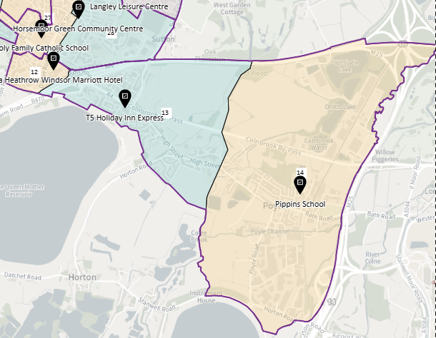
PD No. | Polling District | Polling Place | No. of Electors | Status
12 | CPA | The Marriott Hotel,  Ditton Road, SL3 8PT | 826 | New
13 | CPB | The Holiday Inn,  London Road, SL3 8QB | 2607 | New
14 | CPC | Pippins School,  Raymond Close, SL3 0PR | 1576 | Existing
Total electors: 5009
Ward has been divided into 3 polling districts due to geographical size of the area and to accommodate Colnbrook With Poyle parish.
CPA New polling district and station covering small area from Langley Kedermister ward (LKC). NB: this area is not a part of Colnbrook With Poyle parish.
CPB Existing CPA polling district and part of CPB.
CPC Existing parts of CPB & CPC polling districts west of stream.

Elliman Ward
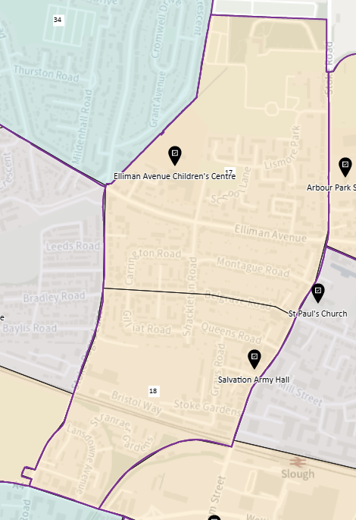
PD No. | Polling District | Polling Place | No. of Electors | Status
17 | ELA | James Elliman Academy, (Children’s Centre),  Elliman Avenue, SL2 5BA | 1953 | Existing
18 | ELB | The Salvation Army Hall,  53 Stoke Road, SL2 5BW | 1632 | Existing
Total electors: 3585
ELA & ELB Existing polling districts ELA and ELB (part) retained. Boundary to run along Belgrave Road (North/South) split – no significant change.

Farnham Ward
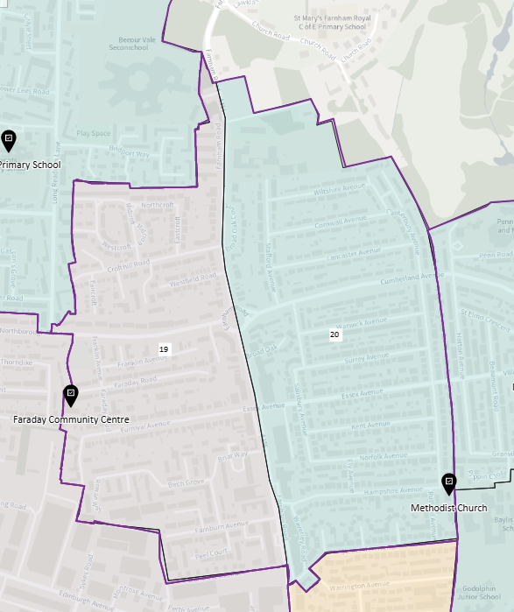
PD No. | Polling District | Polling Place | No. of Electors | Status
19 | FAA | The Faraday Social Club,  Faraday Road, SL2 1RP | 2175 | Existing
20 | FAB | Methodist Church,  Hampshire Avenue, SL1 3AQ | 2753 | Existing
Total electors: 4928
FAA & FAB Retention of existing polling districts FAA & FAB (East/West) spilt.

Haymill Ward
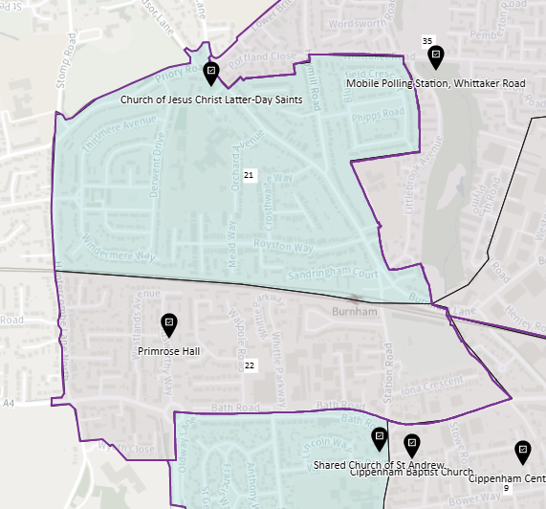
PD No. | Polling District | Polling Place | No. of Electors | Status
21 | HLA | Church of Jesus Christ of Latter-Day Saints, Leaholme Gardens, SL1 6LD | 2813 | Existing
22 | HLB | Primrose Hall,  48 Goldsworthy Way, SL1 6AG | 2201 | Existing
Total electors: 5014
HLA & HLB Ward divided into 2 polling districts split by railway line (North/South) split – no significant change.

Herschel Park Ward
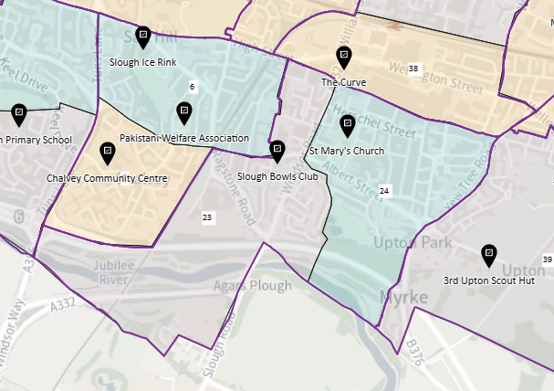
PD No. | Polling District | Polling Place | No. of Electors | Status
23 | HPA | Slough Bowls Club,  50 Chalvey Road East, SL1 2LR | 2349 | Existing
24 | HPB | St Mary’s Church,  34-40 Church Street, SL1 1PJ | 2521 | Existing
Total electors: 4870
HPA & HPB Ward divided into 2 polling districts split by A332 running down Upton Park (East/West) split – no significant change.

Langley Foxborough Ward
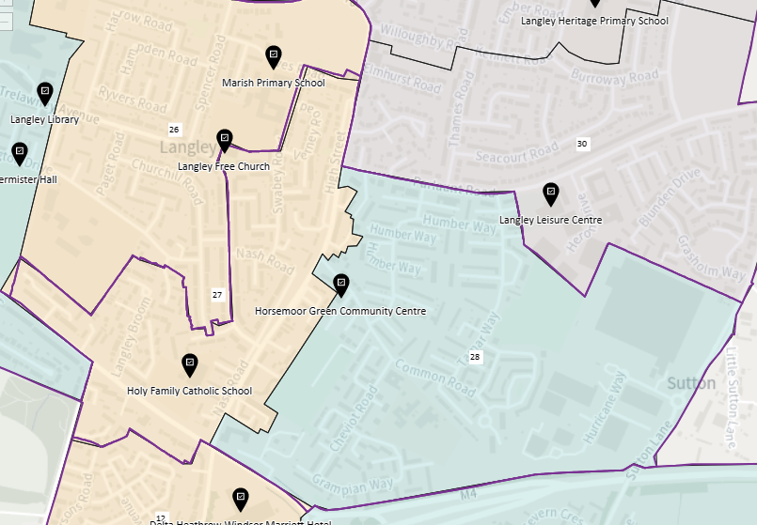
PD No. | Polling District | Polling Place | No. of Electors | Status
27 | LFA | Holy Family Primary School,  High Street, SL3 8NF | 1868 | Existing
28 | LFB | Horsemoor Green Community Centre, Spitfire Close, SL3 8JU | 2540 | Existing
Total electors: 4408
LFA Formed by parts of polling districts LKB & LKC from Langley Kedermister ward (East/West) split.
LFB Extensively the old FOX polling district from Foxborough ward – no significant change.

Langley Marish Ward
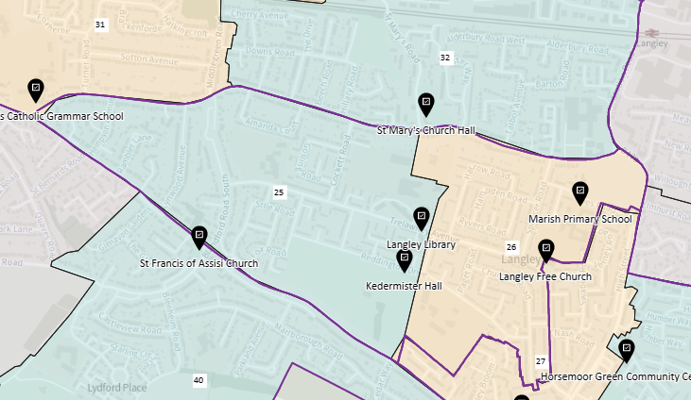
PD No. | Polling District | Polling Place | No. of Electors | Status
25 | LAA | Langley Library, Trelawney Avenue, SL3 7UF  or  Kedermister Hall, Kedermister Park, Reddington Drive, SL3 7TP | 2764 | Library: New  and  Kedermister Hall: Existing
26 | LAB | Langley Free Church, 100 Trelawney Avenue,SL3 8RW  or  Marish Primary School,  Swabey Road, SL3 8NZ | 2041 | Free Church: Existing  and  School: New
Total electors: 4805
LAA Options are to continue the use of Kedermister Hall or move to Langley Library (single polling station).
LAB Options are to use Langley Free Church or Marish Primary School.

Langley Meads Ward
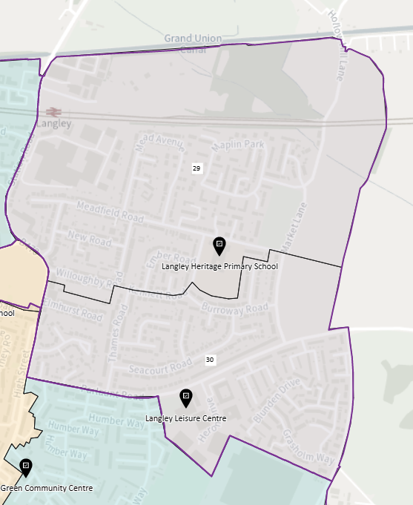
PD No. | Polling District | Polling Place | No. of Electors | Status
29 | LMA | Langley Heritage Primary School,  Kennett Road, SL3 8EQ | 2280 | Existing
30 | LMB | Langley Leisure Centre,  Parlaunt Road, SL3 8BA | 2340 | Existing
Total electors: 4620
LMA & LMB Ward split into 2 polling districts (North/South) split along existing polling districts LMB and LMC (Langley St. Mary’s ward) – no significant change.

Langley St Mary’s Ward
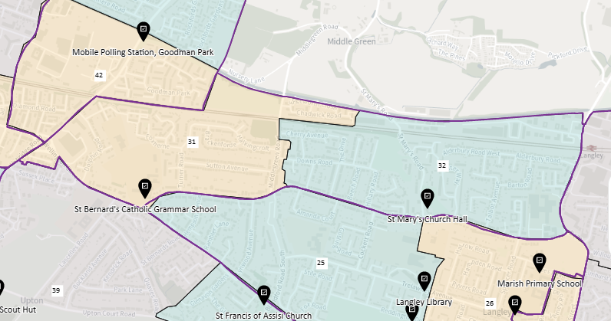
PD No. | Polling District | Polling Place | No. of Electors | Status
31 | LSA | St Bernard’s Catholic Grammar School, Langley Road, SL3 7AF | 1817 | Existing
32 | LSB | St Mary’s Church Hall,  2 St Mary’s Road, SL3 7ER | 2791 | Existing
Total electors: 4608
LSA & LSB Ward split into 2 polling districts (East/West) split by current polling districts UPA (Upton Ward) and LMA (Langley St Mary’s ward).

Manor Park & Stoke Ward
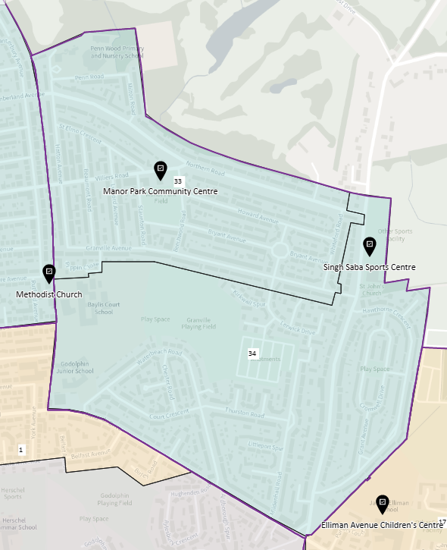
PD No. | Polling District | Polling Place | No. of Electors | Status
33 | MPA | Manor Park Community Centre,  Villiers Road, SL2 1NP | 2781 | Existing
34 | MPB | Singh Sabha Sports Centre,  Stoke Poges Lane, SL1 3LW | 2618 | Existing
Total electors: 5399
MPA & MPB Existing polling districts (BSA & BSB) from Baylis & Stoke ward and part BSC polling district retained – no significant change.

Northborough & Lynch Hill Valley Ward
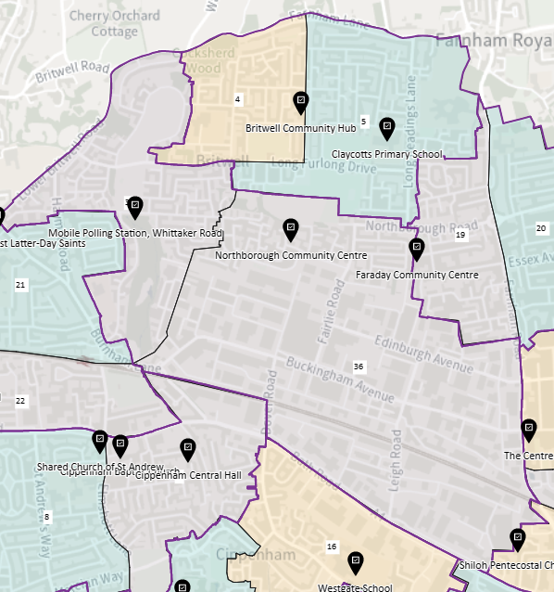
PD No. | Polling District | Polling Place | No. of Electors | Status
35 | NLA | Mobile Unit (portacabin),  Whittaker Road, SL2 | 2411 | Existing
36 | NLB | Northborough Community Hall,  101 Pevensey Road, SL2 1UG | 2195 | Existing
Total electors: 4606
NLA Extensively existing polling district HLB from Haymill & Lynch ward.
NLB Extensively existing polling district BNC from Britwell & Northborough ward.

Slough Central Ward
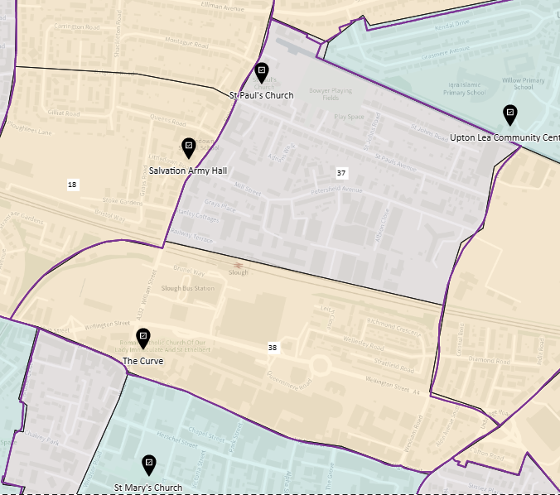
PD No. | Polling District | Polling Place | No. of Electors | Status
37 | SCA | St Paul’s Church,  132 Stoke Road, SL2 5AS | 2245 | Existing
38 | SCB | The Curve Library,  10 Wellington Street, SL1 1XY | 1372 | New
Total electors: 3617
SCA & SCB Ward divided into 2 polling districts (North & South) split by main railway line.

Upton Ward
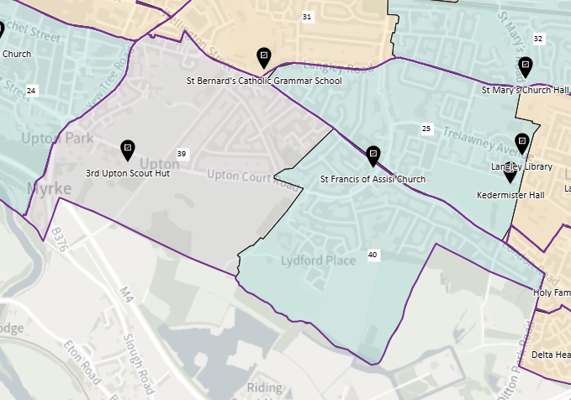
PD No. | Polling District | Polling Place | No. of Electors | Status
39 | UAA | 3RD Upton Scout Hut,  Upton Court Park, SL3 7LU | 2438 | Existing
40 | UAB | St Francis Church,  Upton Court Road, SL3 7HR | 2541 | Existing
Total electors: 4979
UAA & UAB Ward split into 2 polling districts (East/West) from existing polling districts UPB and UPC of Upton ward – no significant change.

Upton Lea Ward
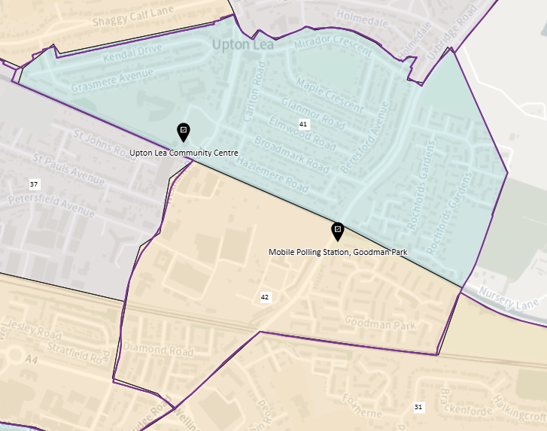
PD No. | Polling District | Polling Place | No. of Electors | Status
41 | UPA | Upton Lea Community Centre,  Wexham Road, SL2 5JW | 3798 | Existing
42 | UPB | Mobile Unit (portacabin),  Goodman Park, SL2 | 1597 | Existing
Total electors: 5395
UPA & UPB Ward split into 2 polling districts (North/South), made up of parts of existing polling districts from Elliman (ELC), Wexham Lea (WLC), and Central (CEB) wards.

Wexham Court Ward
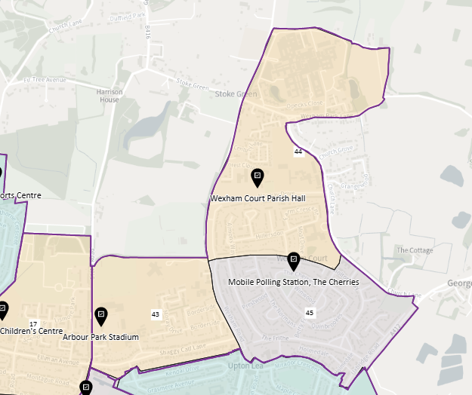
PD No. | Polling District | Polling Place | No. of Electors | Status
43 | WCA | Arbour Park Stadium,  Stoke Road, SL2 5AY | 1042 | Existing
44 | WCB | Wexham Court Parish Hall,  Norway Drive, SL2 5QP | 1490 | Existing
45 | WCC | Mobile Unit (portacabin),  The Cherries, Wexham, SL2 | 2332 | Existing
Total electors: 4864
To accommodate Wexham Court parish area the ward has been split into 3 polling districts.
WCA Existing polling district from Elliman ward (ELC). Non-Parish part.
WCB Existing Wexham Lea polling district WLA – no change.
WCC Existing Wexham Lea polling district WLB – no change.

